*Laboratory Report*

**INTERNET TECHNOLOGIES LAB.**

**CAP5004L**

**School of Engineering**

**Department of Computer Science and Engineering**

|  |  |
| --- | --- |
| **Submitted By** | |
| **Student Name** | Amit |
| **Roll Number** | 180020307001 |
| **Section/Group** |  |
| **Department** | Computer Science and Engineering |
| **Session/Semester** | 2020-21/ Odd Semester |
| **Submitted To** | |
| **Faculty Name** | Ms. Manka Sharma |



**GD Goenka University**

Sohna road, Gurugram, Haryana

**Table of Content**

|  |  |  |  |
| --- | --- | --- | --- |
| Sl No | Date | Aim of the Experiment | Signature/date |
|  |  |  |  |
|  |  |  |  |
|  |  |  |  |
|  |  |  |  |
|  |  |  |  |
|  |  |  |  |
|  |  |  |  |
|  |  |  |  |
|  |  |  |  |
|  |  |  |  |

|  |  |  |
| --- | --- | --- |
| **Experiment No-4.1** |  | **Date:** |

**Aim of the Experiment:**

Write a program in javascript to create two variables and print their values in the

paragraph tags.

**Source Code - index.html**

<!DOCTYPE html>

<html lang="en">

<head>

<meta charset="UTF-8">

<meta name="viewport" content="width=device-width, initial-scale=1.0">

<title>JS Experiments</title>

</head>

<body>

<div>

Result:<p style="display: inline-block;"></p>

</div>

<script>

var x = 10,

y = 20;

document.getElementsByTagName('p')[0].innerText = `${x}, ${y}`;

</script>

</body>

</html>

**Output**

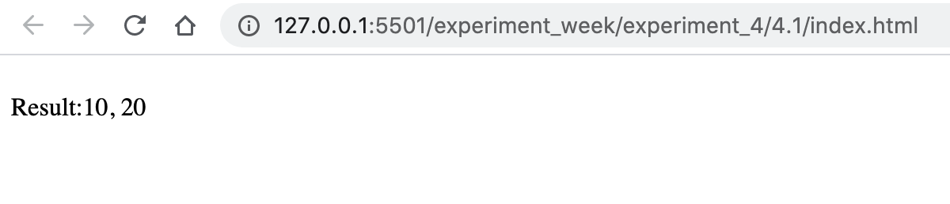

|  |  |  |
| --- | --- | --- |
| **Experiment No-4.2** |  | **Date:** |

**Aim of the Experiment:**

Write a program in javascript to accept the values from the user of two variables and print it in the paragraph tags.

**Source Code - index.html**

<!DOCTYPE html>

<html lang="en">

<head>

<meta charset="UTF-8">

<meta name="viewport" content="width=device-width, initial-scale=1.0">

<title>JS Experiments</title>

</head>

<body>

<div>

Result:<p style="display: inline-block;"></p>

</div>

<script>

var x = prompt(),

y = prompt();

document.getElementsByTagName('p')[0].innerText = `${x}, ${y}`;

</script>

</body>

</html>

**Output**

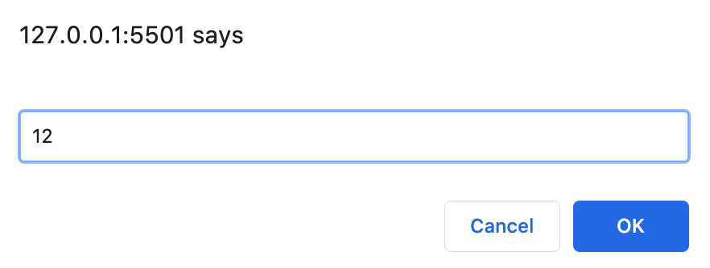

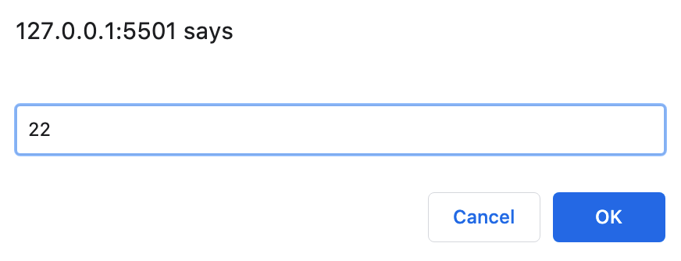

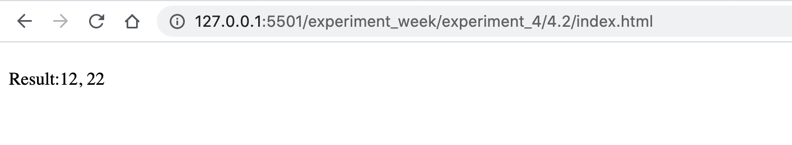

|  |  |  |
| --- | --- | --- |
| **Experiment No-4.3** |  | **Date:** |

**Aim of the Experiment:**

Write a program in javascript to accept two integer values from the user of two variables and print their sum, product, modulus, subtraction, division, and exponentiation.

**Source Code - index.html**

<!DOCTYPE html>

<html lang="en">

<head>

<meta charset="UTF-8">

<meta name="viewport" content="width=device-width, initial-scale=1.0">

<title>JS Experiments</title>

</head>

<body>

<div>

Sum : <p id="sum" style="display: inline-block;"></p>

<br>

Product: <p id="pro" style="display: inline-block;"></p>

<br>

Modulus: <p id="mod" style="display: inline-block;"></p>

<br>

Subtraction: <p id="sub" style="display: inline-block;"></p>

<br>

Division: <p id="div" style="display: inline-block;"></p>

<br>

Exponentiation: <p id="exp" style="display: inline-block;"></p>

<br>

</div>

<script>

var x = prompt(),

y = prompt();

// SUM

document.getElementById('sum').innerText = x + y;

// PRODUCT

document.getElementById('pro').innerText = x * y;

// MODULUS

document.getElementById('mod').innerText = x % y;

// SUBTRACTION

document.getElementById('sub').innerText = x - y;

// DIVISION

document.getElementById('div').innerText = x / y;

// EXPONENTIATION

document.getElementById('exp').innerText = x ** y;

</script>

</body>

</html>

**Output**

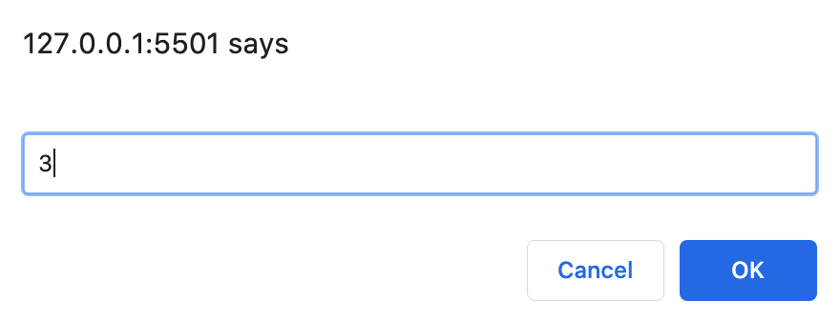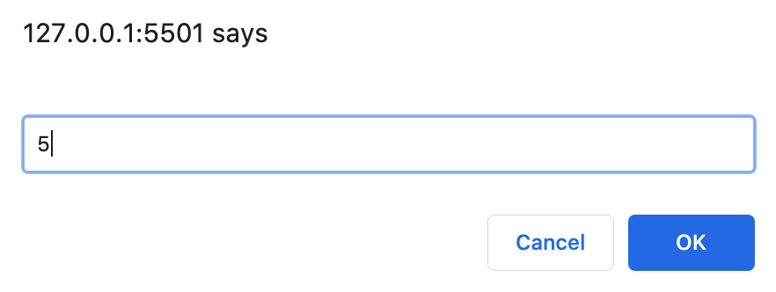

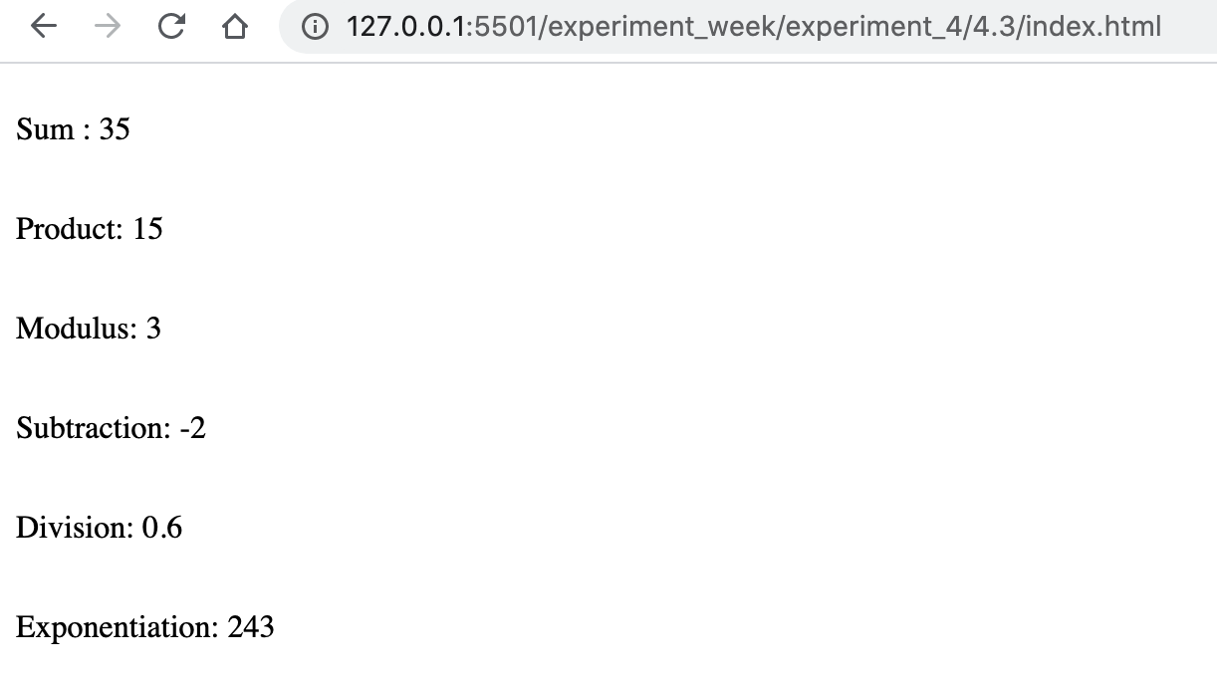

|  |  |  |
| --- | --- | --- |
| **Experiment No-4.4** |  | **Date:** |

**Aim of the Experiment:**

Write a program in javascript to accept two float values from the user of two variables and print their sum.

**Source Code - index.html**

<!DOCTYPE html>

<html lang="en">

<head>

<meta charset="UTF-8">

<meta name="viewport" content="width=device-width, initial-scale=1.0">

<title>JS Experiments</title>

</head>

<body>

<div>

Result:<p style="display: inline-block;"></p>

</div>

<script>

var x = prompt(),

y = prompt();

document.getElementsByTagName('p')[0].innerText = x + y;

</script>

</body>

</html>

**Output**

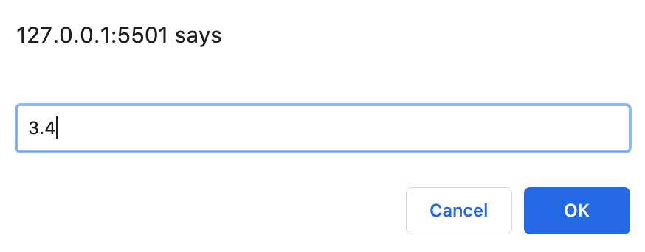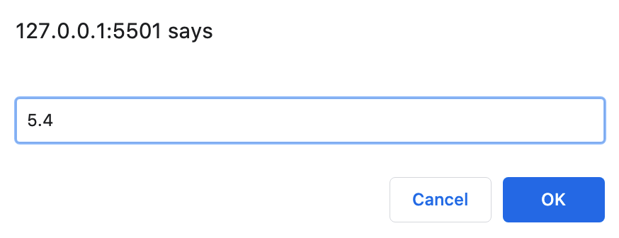

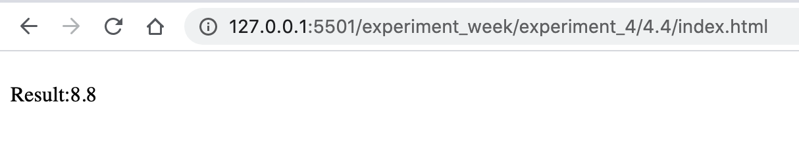

|  |  |  |
| --- | --- | --- |
| **Experiment No-4.5** |  | **Date:** |

**Aim of the Experiment:**

Write a program in javascript to accept two strings from the user and concatenate it.

**Source Code - index.html**

**Output**

